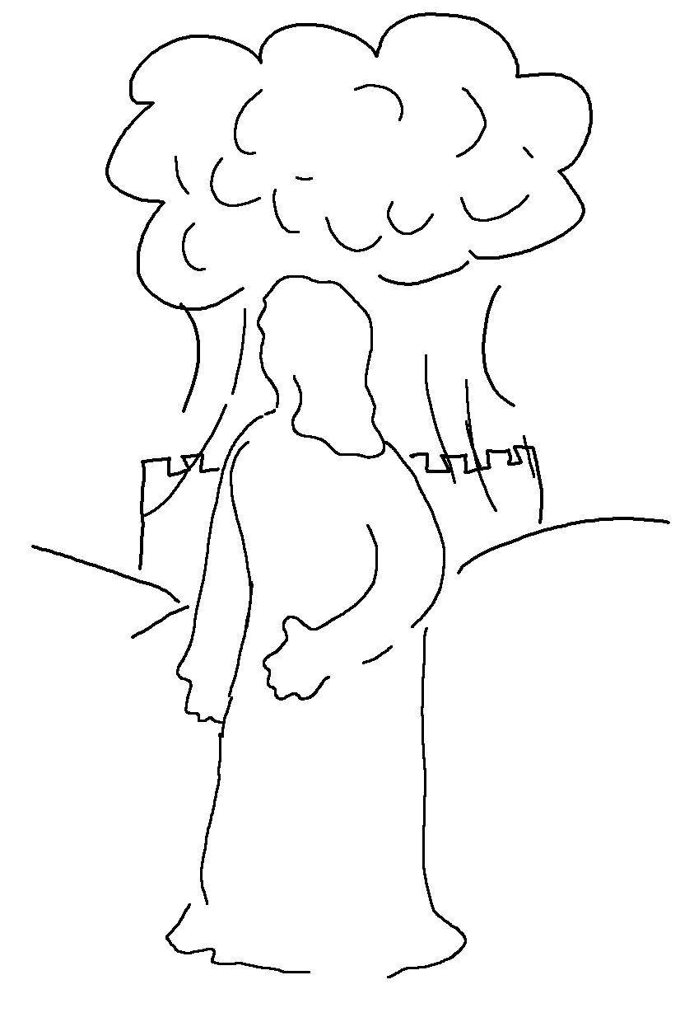
The eyes of the Lord
watch over
those who do right… 1 Peter 3:12_{NLT}

